EAirPlay APK installation SOP.
1.Please download and save “EAirPlay.apk” to USB flash drive (format: FAT32) and plug in USB interface on your projector.

2.Go to “File Management”.
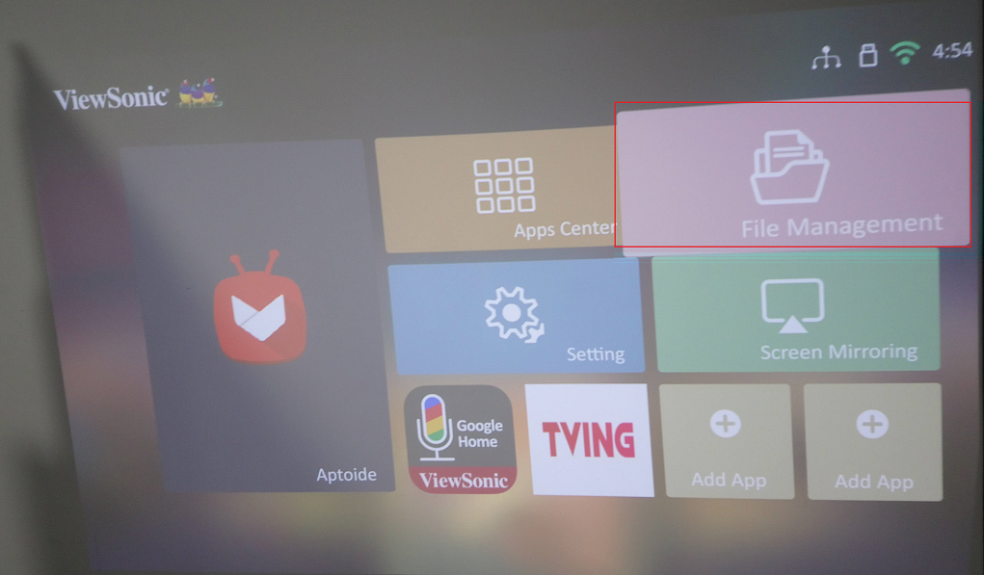
3.Select ”USB”-> “EAirPlay.apk” and open “EAirPlay.apk” file.
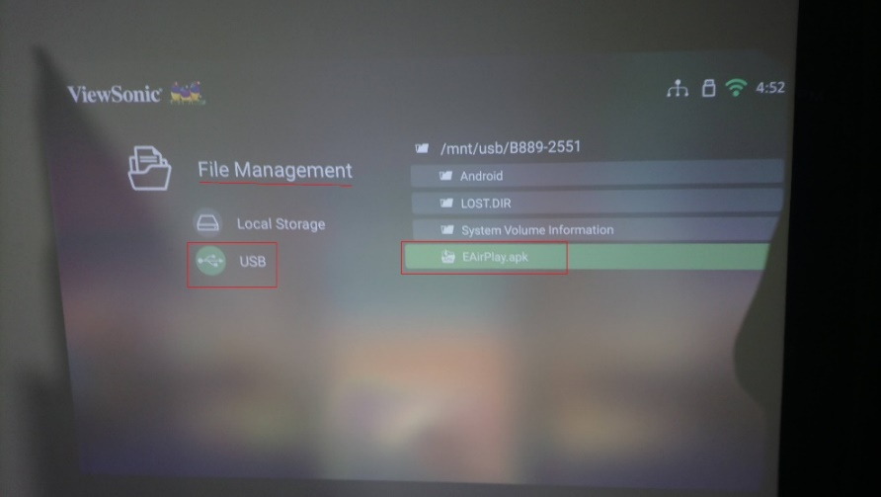

4.Select “New”-> “Install”.
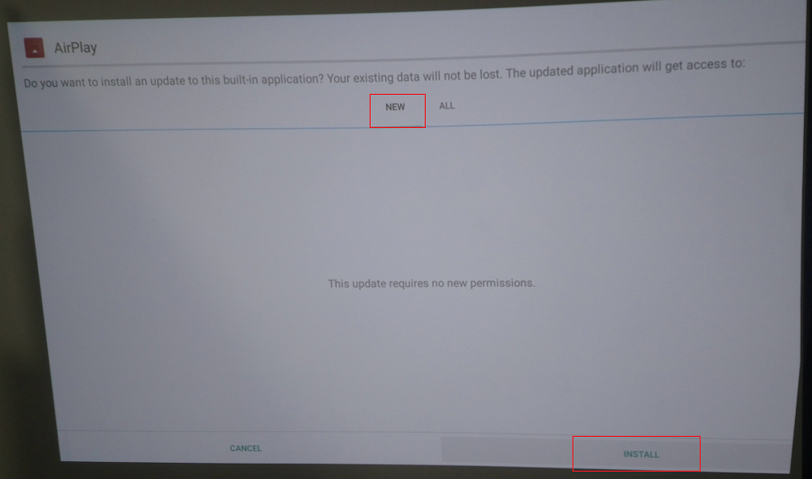

5.Please select “Done” and the installation of EAirPlay.apk is done.
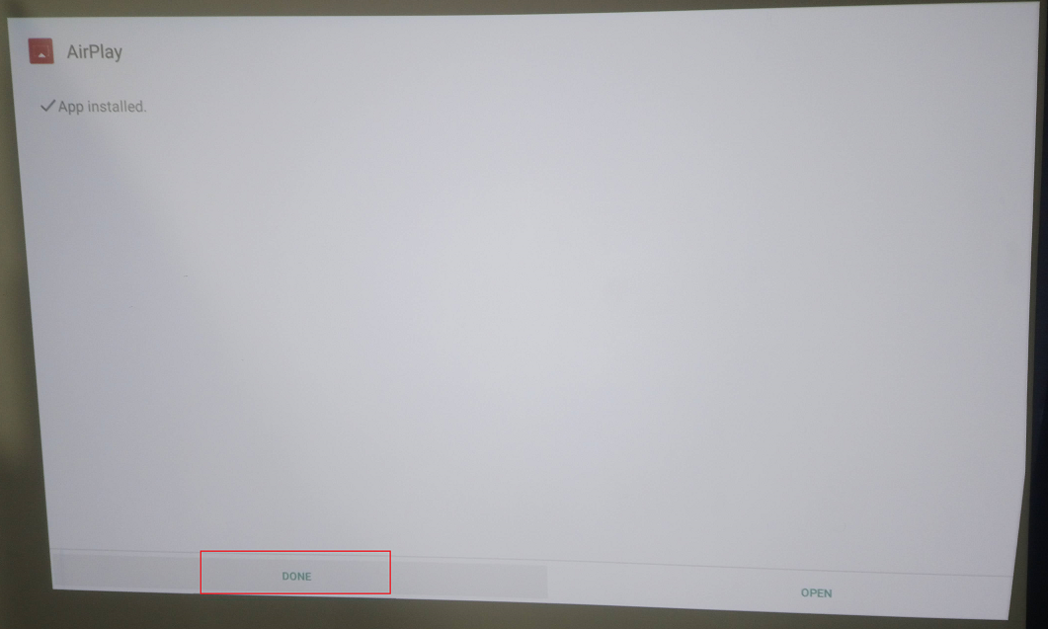

6.Reboot your projector after the APK is installed.
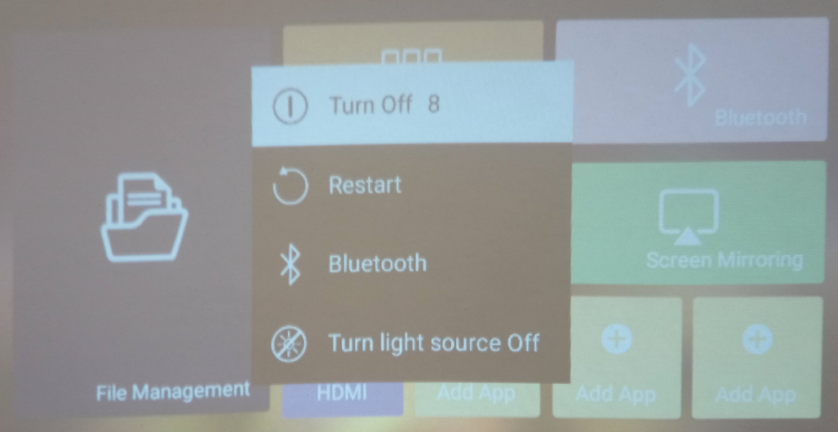

7.Go to “Screen Mirroring”
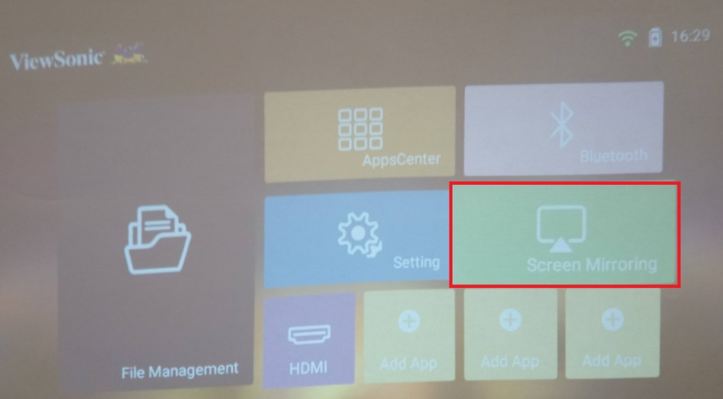
8.Connect iPhone with projector via AirPlay and select the Projector ID which users would like to connect with.
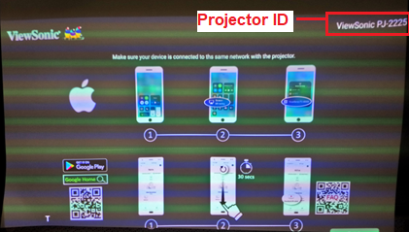

9.Screen Mirroring is working well via AirPlay on iPhone.
