How to create IFP50 power off and on Run Script job in SureMDM
1. Click “Jobs”.
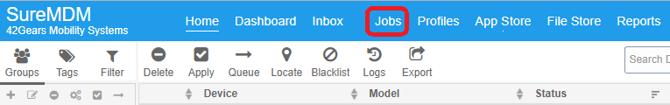
2. Click “New Job”
3. Click “Android”
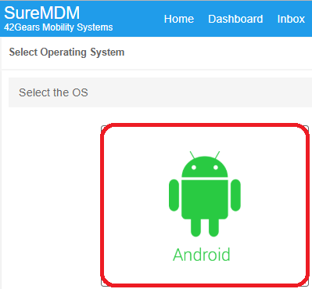
4. Click “Run Script”
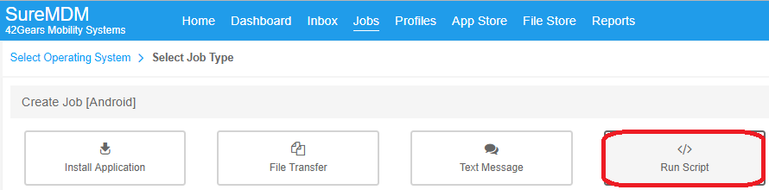

5. You can key in any wording in “Job Name” column, we suggest to key in “POWER OFF(Sleep mode)”. Key in “am broadcast -a com.seewo.intent.action.FAKE_STANDBY_REQ_ENTER” in “Script” column then click “Save”.
Note: You don’t need to change the Standby mode to sleep, let comment will let IFP50 go to sleep directly.
If you want to add POWER OFF(Hibernate mode), you need to key in “am broadcast -a com.seewo.power.normaloff” in “Script” column then click “Save”.
Note: You can’t use POWER ON(Sleep mode) to power on IFP50.
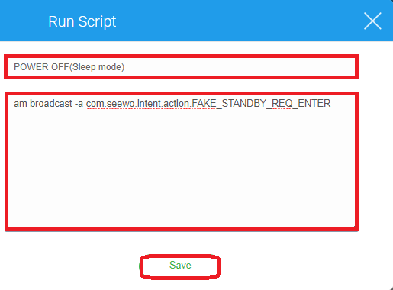
6. You can see “POWER OFF(Sleep mode)” in joe list.
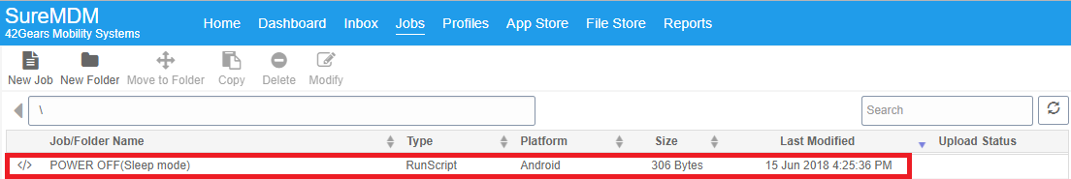

7. Repeat step 2 to 4, key in “POWER ON(Sleep mode)” in “Job Name” column. Key in “am broadcast -a com.cvte.newmcuto901.ACTION_BROADCAST_BACKLIGHT_CONTROL” in “Script” column then click “Save”.
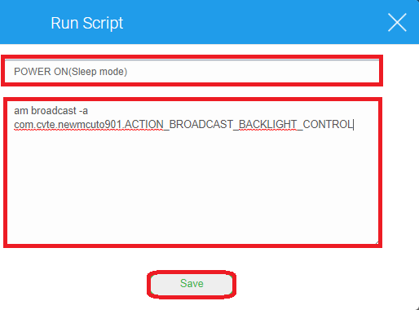
8. You can see “POWER ON(Sleep mode)” in joe list.
9. Click Home back to home page then click mouse left button to select a device.
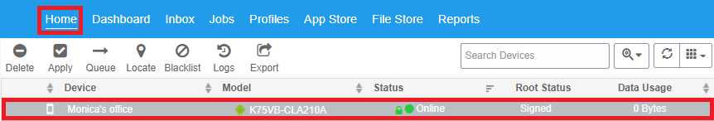
10. Click Apply.
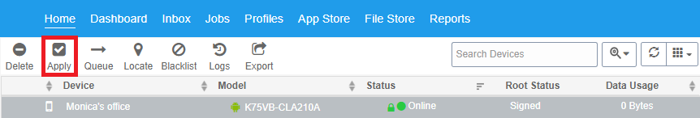

11. Select POWER OFF(Sleep mode) then click Apply, the device you select will be power off to sleep mode.
Note: The Status will keep Online. If you select POWER OFF(Hibernate mode), the Status will change to Offline.
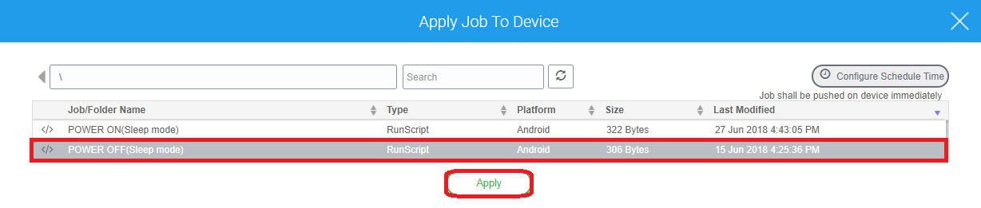
12. Repeat 10, Select POWER ON(Sleep mode) then click Apply, the device you select will be power on.
Note: Only useful when the device use POWER OFF(Sleep mode) to power off by previous step.

