How can I fix EP5520T into floor?

1. To plant 4 bolts on ground.

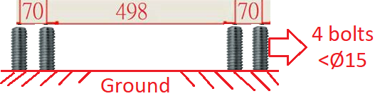

2.      Install EP5520_EP5520T with the bolts.

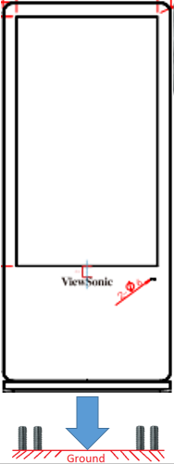

3.      Tighten 4 nuts with the bolts from access door.

